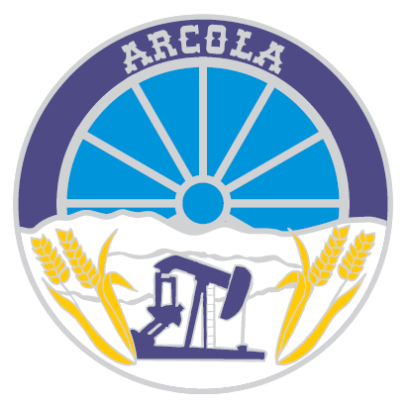
Town of Arcola
Policy Manual
Policy Description: Policy Number: Utility-001
Water & Sewer Line Installations Date Approved: February 9th, 2016
Date Revised:

Purpose of Policy: To ensure consistency and clarity for anyone wanting to apply for a water and sewer line connection to the mains in the Town of Arcola.
- Anyone purchasing an un-serviced lot in the Town of Arcola is responsible for the entire cost of connecting to the Town’s water and/or sewer mains, including (if applicable) the cost of repair to the street pavement and curb and any landscaping to the boulevard.
- Anyone requesting a new water or sewer connection where one already exists is responsible for the entire cost of connecting to the Town’s water and/or sewer main, including (if applicable) the cost of repair to the street pavement and curb and any landscaping to the boulevard, except if the replacement is recommended by the Town.
- Process:
  - The homeowner who intends to replace the water or sewer line is to make arrangements to do so by contacting the Town Office.
  - All applications for new water and/or sewer lines must be reviewed and approved by Council or its designate prior to any work being undertaken.
  - The Town will arrange with a Town-approved contractor to schedule the work, and will ensure that sufficient material (pipes and fittings) are on hand.
  - Once the work is completed, the contractor is to make out the invoice to the homeowner for the installation of the water and/or sewer line and is to list the footage from the main to the property line and from the property line to the house.
I, , have received a copy and understand the Town of Arcola’s policy on water and sewer line installations.
Signature Date

