
Inside this issue:
Winter Landfill
Hours 2
Remembrance Day
Ceremony 2
Holiday Garbage &
Recycling 3
Lighting Contest 3
Reminders 3

Wastewater Lagoon Update
Unfortunately we have hit a bump in the road pushing back our lagoon expansion construction quite a bit. With all of the rain it is causing ground water to fill up the new lagoon cell. We now have to do some dewatering which calls for trenching and pumping the excess water. The plan is to pump the water to the nearby creek which will then follow the normal water path. First we have to test the water to make sure it is safe, and then get written approval from Water Security Agency. This may take some time so it pushes everything back. We are optimistic though that construction will still be done before winter in late 2017.

Town of Arcola
Volume 3, Issue 6
November, 2016

For Your Information

Election Results

The election votes were calculated and the results were as follows:
Mayor:
- Keith Erick
Councillors:
- Colin Brownridge
- Elaine Hislop
- Cindy Kolenz
- Scott Tessier
- Matt Wheeler
- Marius Wotta
We would like to say a big thank you to all the other candidates that ran for council. Your interest in serving the community is greatly appreciated, and to be commended!
Also a big thank you to everyone that came to vote. The future of Arcola is shaped by your decisions. We are glad to see so many residents care about the growth of this town.
General Municipal Elections for every City, Town and Village were held on Wednesday October 26th. The term for council is 4 years ending in October of 2020.
The Town of Arcola had 2 people running for Mayor and 8 people running for council, therefore we had a full election.
With 181 Arcola residents coming to vote, we guessed that was about 45% of eligible voters.

Page 2

For Your Information

Winter Landfill Hours

As the cold weather approaches, leaves are falling and everyone is finishing up their yard work for the year. The amount of garbage coming in slows down, so we cut back on the hours. As a result winter landfill hours will be effective starting on October 18th.
Tuesday: 1-2 pm
Saturday: 1-2 pm
Fees:
Small trailer or truck - $7
½ ton truck/trailer - $20
3 ton trucks/single axle - $100
Couches & carpets - $20
Loveseats or chairs - $15
Fridges, stoves, washers - $15 each
Water heaters, small metal items - $7 each
Leaves/Branches – Free
For your information:
With upgrades to our landfill we now have strict rules as to what can be burned. Only clean wood and leaves can be put in our burn pile. This means any wood with paint or stain has to be thrown into our garbage dumpster, therefore costing you per load.



“Winter landfill hours will be effective starting on October 18th.”

Remembrance Day Ceremony


Page 2
On Friday, November 11th, at 10:45am at the Optimist Theatre, a Remembrance Day Service will be held to honour brave soldiers, both past and present.
For your information, any money donated for poppies goes toward the Legion, and any offerings will go to the Wounded Warrior Fund.
Come pay your respects and then enjoy a pot luck lunch at the Optimist Legion Hall following the service.

For Your Information
Page 3

Holiday Garbage & Recycling

Garbage Day is Friday, December 23 and recycling is Monday, December 26 as per Regens Disposal Collection Schedule.

Did you know that you can get garbage & recycling reminders directly from Regens Disposal?! You can sign up for free text or email reminders, as well as print off a schedule. Go to www.regensdisposal.ca and on the home page under “collection schedules and reminders” follow the prompts. If you are having any issues stop in the Town Office as we always have extra copies of the schedule here.

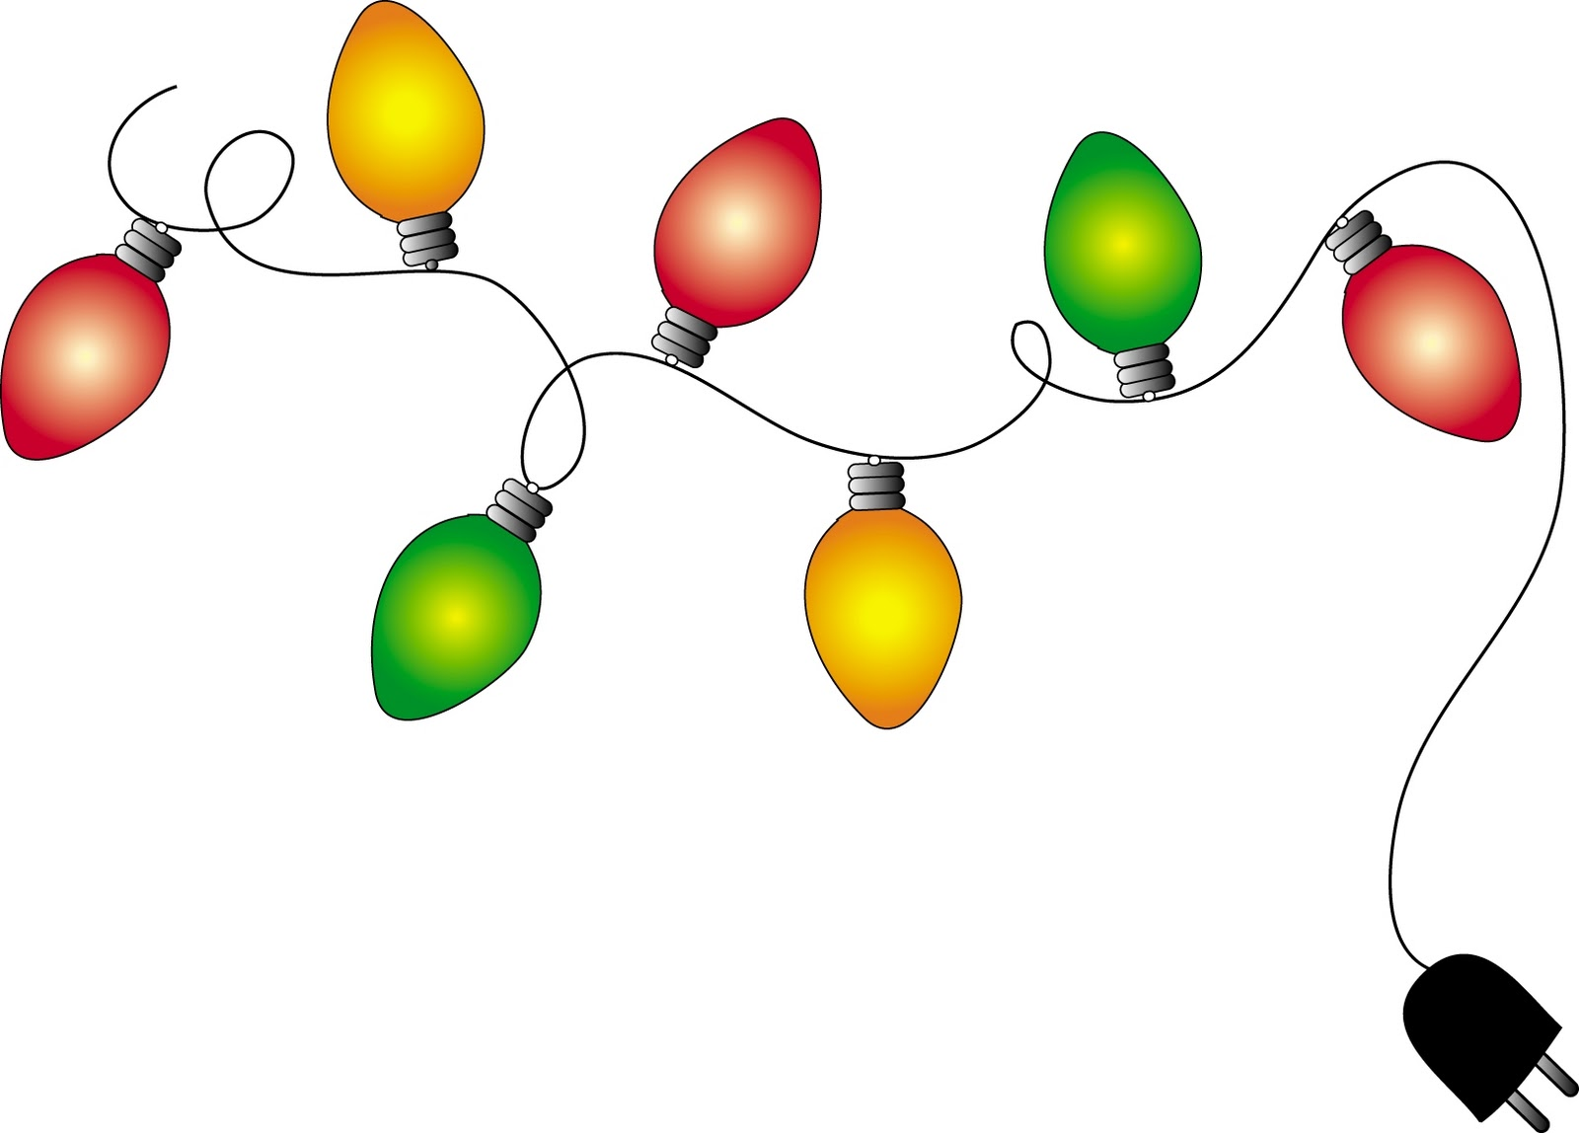

Lighting Contest

We are excited to announce our 1st Christmas Decorating Contest. This is the perfect time to utilize all your lights and inflatables! We will be judging both residential and commercial places. The judging will take place the week of December 11th to the 18th. We are hoping for great participation to be able to make this an annual event. This year’s contest is for BRAGGING RIGHTS, and maybe next year there will be prizes!!

Reminders
- 2016 taxes are to be paid in full by December 31st or there will be a 5% interest added onto your account on January 1st. If still not paid, a 5% interest will be added on again on February 1st. If you do not know what your account balance is at, please call the office.
- If any residents have water and sewer bills that are outstanding, they will be sent a letter stating when they have to be paid by. If not paid by that date, the Town can turn off the water until payment is received. There will also be a $100 charge to turn the water back on as per our bylaw 23-2013.
- Leaves, branches and garden refuge will no longer be picked up by Town employees for the rest of the year. We will continue again come summer 2017.
- Don’t forget to check out our town website to see what’s happening in town: www.townofarcola.ca.

