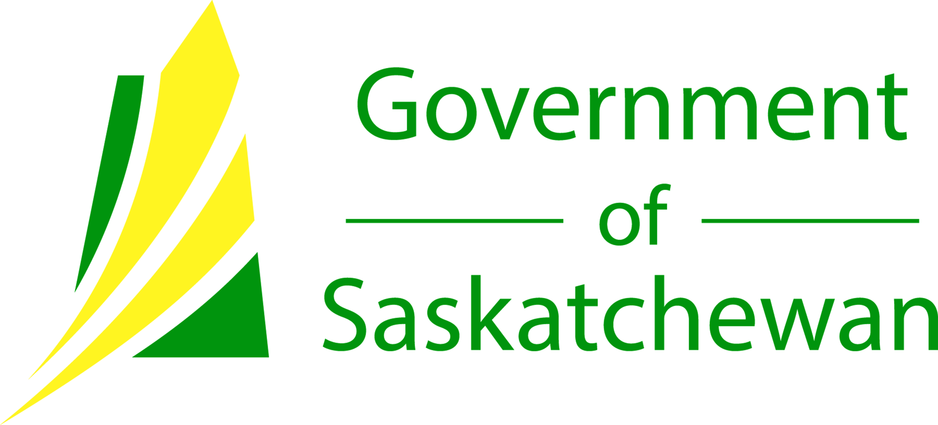

The Town of Arcola is pleased to announce that their wastewater lagoon expansion project will receive funding through the New Building Canada Plan – Small Communities Fund. The total estimated project cost of $3,300,000 will be shared on a one-third basis, with the Government of Canada committing $1,100,000, the Government of Saskatchewan committing $1,100,000, and the Town of Arcola contributing $1,100,000.
The Town of Arcola plans to construct a sewage lagoon with new primary cell, expanded secondary cell, force main, outlet structure and all associated works. The project will improve the reliability and performance of wastewater collection for the residents of Arcola.
This project is one of 11 recently announced in Saskatchewan, bringing the total to 37 projects approved in the province so far under the Small Communities Fund.
Quotes
“Safe drinking water and effective wastewater processing facilities are critical to providing sustainable, livable communities. The Government of Canada is proud to invest in these 11 infrastructure projects, all of which are in Saskatchewan communities of less than 2,000 people. The projects will improve local infrastructure and have a positive and lasting impact on the quality of life of these residents.”
The Honourable Ralph Goodale,
Minister of Public Safety and Emergency Preparedness
“Our government is pleased to have partnered with the Government of Canada to invest more than $5 million toward improving critical water and wastewater systems in 11 communities across the province. Key investments like this will help make life better for citizens both now, and well into the future.”
The Honourable Jim Reiter,
Minister of Government Relations

Town of Arcola
Volume 3, Issue 2
March, 2016

For Your Information

Arcola Receives $2.2 Million for Lagoon

Inside this issue:
$2.2 Million
Continued 2
Prairie Place
Bathroom Renos 2
Paying Bills
Online 3
Burnt Out
Street Lights 3
Employment
Opportunities 4
Dog and Cat
Licenses 4

$2.2 Million Continued…

“Arcola is very pleased with this announcement from the current Provincial and Federal governments. This will provide citizens of Arcola with a sustainable future, continued growth, and improve the environmental impact. Our wastewater lagoon expansion project would not be possible without this funding.”
Harry Laurent
Mayor of Town of Arcola
Associated Links
To learn more about the Small Communities Fund, please visit http://www.infrastructure.gc.ca/plan/sc-cp-eng.html.
To learn more about other projects recently announced in Saskatchewan under the Small Communities Fund, please visit http://www.saskatchewan.ca/government/news-and-media/2016/february/26/eleven-infrastruture-projects.
To keep up to date with the progress of the Town of Arcola’s project, please visit www.townofarcola.ca

For Your Information
“This will provide citizens of Arcola with a sustainable future, continued growth, and improve the environmental impact.”

Prairie Place Bathroom Renovations

The Town of Arcola and the Prairie Place Complex Board would like to extend their thanks to the Community Initiatives Fund- Community Places and Spaces Program. Prairie Place Complex has been accepted for funding under this program in the amount of $12,500 to go towards bathroom renovations. Without this grant it would not be possible to do these much needed upgrades!
Over a few weeks in February and the start of March contractors will be busy gutting the bathrooms, and then adding and replacing the toilets, sinks, flooring, stalls and vanities. Check out www.townofarcola.ca later in March for pictures of the completed project!

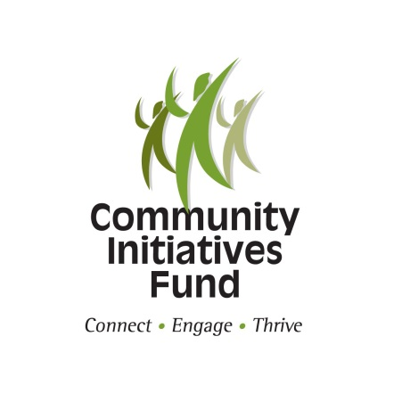

Page 2

Page 2

Page 3
For Your Information

Paying Bills Online

You can pay your town bills online through your banking institution. Once you sign in, go to “pay a bill”, and add the town as a payee. Search for us under Arcola (Town of). There will be different categories such as “Property Tax” “Utilities”. Click the type of bill you wish to pay. (Note- If “add payee” does not come up, contact your local branch.)
Please remember to use the correct account

numbers when paying your utility bills or taxes on line. The utility account number is located on your bill in the top right below the date. For taxes, use the roll number, which is located in the top left of the tax notice, below the address.
When we receive notice that an on-line payment has been made it includes the account number and the name of the person making the

payment. If the person making payment is not listed on the account we may not apply the payment correctly. Please let us know if someone else will be paying the bills so we know it’s not a mistake!
If you have trouble finding your account number, or need other help just give us a call or email and we would be glad to help you.

Burnt Out Street Lights

If anyone notices a burnt out street light or anything wrong with a post, please call the town office right away.
We report these to Sask Power so they can get fixed as soon as possible!
If you notice on a weekend or during the night you can leave us a
message or send us an email. You can also report it directly to Sask Power by going to their website: www.saskpower.com
At the bottom of the home page click on street light troubles, then on the next page click on view map. If you then type in Arcola, it will show you a
map of the town.
Any street lights that are red have already been reported. If it has not been reported yet, just click on the green light bulb and follow the prompts.

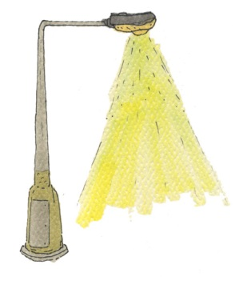

Page 4
For Your Information

Employment Opportunities
Assistant Administrator
Due to retirement, an Assistant Administrator Position is available with the Town of Arcola. This is a part-time position. Office experience is an asset. Preference will be given to an individual who has, or is willing to take the LGA classes.
For more details please contact the Town of Arcola at 306-455-2212 or arcadmin@sasktel.net.
Please send resumes stating work experience, wage expectations and at least three references, by April 1, 2016 to: Town of Arcola, Box 359, Arcola, SK, SOC OGO, or by e-mail to arcadmin@sasktel.net.
Summer Student (Maintenance Helper)
The Town of Arcola is looking for a summer maintenance employee. The primary duties will include mowing, weed whipping, painting and general town maintenance. This worker will also help the senior public works employees when needed. Equipment experience considered an asset. Valid driver’s licence required. Ideal for a student, but not limited to students.
Please bring resumes to the Town Office or send to arcadmin@sasktel.net.

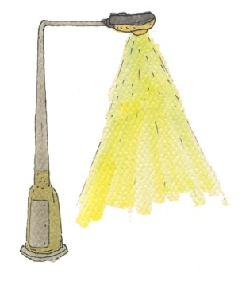


Dog and Cat Licenses are due!

Do you have a dog or cat?
A reminder that dog and cat licenses are to be filled out and paid for every year! It only costs $10 and you will receive a tag.
If your animal is lost it is much easier to find out who the owner is if he/she has a tag. If a dog or cat is caught running at large, and has no tag, it can be put into our pound. The pound costs are $50 per day, and after 3 days if not claimed and the bills not paid, the administrator can dispose of the animal. If the animal has a tag, we can contact the owner right away and give the animal back to them.
We have only about 20 tags bought at this time, and we know there are plenty more animals out there! Please help keep your furry friends records up to date for our benefit and yours!

