

This year Canada turned 150!! We celebrated in Arcola in conjunction with the Arcola Antique Ag Days on Sunday July 2nd. Residents enjoyed the delicious cupcakes, ice cream, juice, face painting, and an awesome firework show to end off the evening. The highlight of the evening was a concert put on by Tenille Arts of Weyburn (now Nashville). She put on an amazing hour and a half show for all ages all thanks to the work of the Arcola Fair & Stampede Board and generous donations from a number of Co-ops in the area.
We would like to give a huge thank you to everyone that volunteered or helped in any way to make this year possible:
Cathy Burton – for making all the delicious cupcakes, and picking up all the supplies.
Brittany Hislop – for doing an awesome job face painting.
Arcola Co-op- for their generous donation to cover half of
the fireworks cost.
Mike Heidinger, Brady Court, Chad George, Shane Smith
and Darryl Arndt– for setting up and running the fireworks.

Inside this issue:
Budget- New
Mill Rates 2
June Flooding
Issues 2
New Foreman 3
Lagoon Progress 3
Mural Committee 3

Canada Day Celebrations

SMAK Attack Results

ARCOLA WON!!
The Town Council and staff would like to thank everyone for their dedication and hard work to help clean up the town. We are so proud of Arcola residents and staff for stepping up and really cleaning up your yards. It was really noticeable how much extra effort and work was done! Especially in such a short time span because of all the rain we experienced.
Thank you for your continued community spirit and pride!

Town of Arcola
Volume 4, Issue 4
July, 2017

For Your Information

Page 2

For Your Information

Budget- New Mill Rates

With major assessment changes this year, Council had to take a good look at the mill rate. It has become a very tough budget year due to Provincial Government cut backs, increased utility costs, extra engineering work, June flooding issues, and now lawyer fees due to a lawsuit against the Town. The finance committee had to meet several times to discuss how we were going to balance the budget without raising taxes to an unmanageable amount.
The mill rate for 2017 has now been approved at 5.5. The following are the mill rate factors for the different classes:
- Residential- 1.2
- Commercial-1.45

*For your information, the 2016 mill rate was 7.5 for Agricultural and Residential, and Commercial also had a mill rate factor of 2.2.

2017 Mill Rate= 5.5
Mill Rate Factor’s:
Residential- 1.2
Commercial- 1.45

June Flooding Issues

On June 9th, the Town of Arcola experienced 4-5 inches of rain in less then 2 hours. Our sewer system simply could not handle that much water in such a short time period. Many residents have their sump pumps hooked into the town sewer system, therefore flooding our lines with storm water. Unfortunately, our lift station is not designed to hold all that rain that comes down, so the pumps cannot keep up and the lift station starts to flood. This calls for immediate action so that basements do not start to flood as well. With new council and a new Town Foreman this situation has not arisen yet so Barry McNeil, the previous Town Foreman, came to the rescue to help us get organized. We had to get vac trucks and 6” trash pumps to help suck/pump out all the rain water coming down the lines. Unfortunately, on Wednesday June 14th we had another 3-4 inches of rain come down. Because the ground was so saturated the water had no where to go so the situation became worse. We had to get vac trucks and more pumps once again to help with the volume of water coming down. The Town did everything we could to try and prevent flooding, but unfortunately there was just too much ground water. Not only did the rain cause issues with the lift station it caused issues at our water treatment plant as well. The surface water up at the springs (which we usually don’t have) is penetrating into our wells causing our water quality to drop. Until this surface water dries up we will continue to have water quality issues. This flooding is becoming an ongoing issue so council is in discussion about what we can do to try and prevent or help these kinds of situations.



Page 2

For Your Information
Page 3

New Foreman


The Town of Arcola Council is excited to announce that we have hired Grant Bassingthwaite as our new Town Foreman. He comes from Yorkton area with over 4 years’ experience in Municipal Government Maintenance. He also has his Class 1 certification in Water Distribution and Treatment, and his Class 1 certification in Wastewater Treatment and Collection.
If you see him make sure to stop and say hi!

Lagoon Progress


The Town of Arcola Council is very impressed with the progress of the lagoon thus far. All the construction for the primary cell is complete and now work is well underway for the secondary cell. This includes desludging the old lagoon, which with a south wind, you may have smelt the last couple weeks. This is not the greatest smell but it does mean progress! JJ Trucking will continue to push hard and work on the berm of the secondary cell.

If all continues to go well construction should be 100% complete by fall.

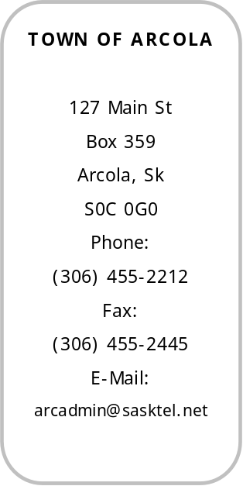

Mural Committee

The Town Council has been approached about painting a big mural somewhere in town. As the Town Council is tied up, both time and money wise, we thought we would put it out to the Town residents. Would there be any interest in forming a Mural Committee, where they would meet to discuss where to get the money, what mural to paint, where, and by whom.
If this would be of interest to you please stop in the Town Office to discuss in more detail.

