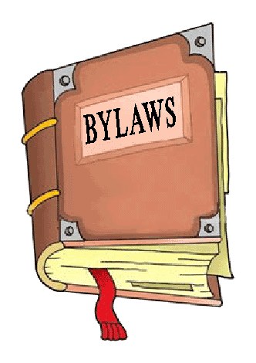
Town of Arcola
Volume 3, Issue 1
January, 2016

For Your Information
There were many changes to the Municipalities Act on November 19th, 2015. These changes affect every municipality in Saskatchewan.
Effective immediately, council members must file a Public Disclosure Statement concerning conflicts of interest, must establish an Employee Code of Conduct, and a Council Procedures Bylaw must be adopted. Because this bylaw deals with many different issues, it is to be made public. Therefore public notice is hereby given that the Council of the Town of Arcola intends to discuss the establishment of a Council Meeting Procedures Bylaw. Council will discuss and approve this new bylaw at their January 12th, 2016 meeting.
Some other requirements that will come into effect in the New Year are a Code of Ethics that council must adopt, as well as a revised Oath of Office that every council member will have to file. Each one of these documents will be filed and made available to the public should anyone so wish to take a look.
These changes were all brought on due to the Final Report of the Inspection and Inquiry into the RM of Sherwood No.159. These changes will help all municipalities, council and employees address situations of municipal conflict of interest that may arise in the future.

Changes to the Municipalities Act

Inside this issue:
Christmas Tree
Pickup 2
Renew Your
Licenses 2
Town Website 2
Snow Removal 3
Happy New Year! 3

Donations

The Town of Arcola would like to thank all residents for their continued support.
We received many donations this year for many different non-profit organizations such as the Fire Department, the Public Library, Prairie Place Complex, Palliative Care, Moose Mountain Health Care Corp, Moose Mountain Health Care Recruitment Committee, and the Cemetery.
Without your support and generous donations some of these organizations would not be able to run- so THANK YOU!


Once again our town maintenance workers will be going around picking up old Christmas trees. Residents can leave their old Christmas trees on the boulevard every Wednesday. They will then take them to the landfill, saving residents a trip. This service will only be provided in the month of January.

Renew Your Licenses

It’s that time of year again! Please come into the town office and renew your business, dog and/or cat licenses.
Business licenses are required for anyone or business that does work in Arcola. The only ones that are exempt from getting a business license are businesses that own a building and pay town taxes.
So for example, if you contract someone out to re-shingle your house, they must come into the office and get a business license.
Dog and Cat licenses are also to be filled out and bought every year. These are $10 each. Please come with an idea of the date of vaccines, most specifically rabies. Once you have, we will give you a tag that is to be worn by your dog or cat at all times.

“… Renew your business, dog and/or cat licenses.”

Town Website

Did you know that the Town of Arcola has a website?
There is tons of information on there from latest news, the Prairie Place Hall schedule, the current Rink schedule, bylaws, policies, to a list of businesses and phone numbers.
Many questions you may have can be answered from the website. For example if you are wondering the hardness of our town water, you can search under Annual Waterworks Reports and the document has the last year’s results. Does the garbage or recycle cart pickup fall on a holiday? Check out our website under Garbage and Recycling, and you will find a link to the pickup schedule for the year.
All of this and more can be found at www.townofarcola.ca



Page 2

Christmas Tree Pickup

For Your Information


Page 3
For Your Information
Winter is upon us again! Town Staff would like to remind everyone to please not park/leave vehicles on the street. Parking vehicles on streets interferes with proper snow removal.
We would also like to remind everyone to be cautious around the snow removal equipment. For your safety, keep a fair
distance away while they are in progress.
Also please do not pile snow on other people’s properties, on boulevards or in front of fire hydrants.
In order for the Town Maintenance workers to do their job your cooperation would be greatly appreciated!

Snow Removal

