

Inside this issue:
Donations 2
Renew Your
Licenses 2
Water Meter
Readings 2
1st Annual Lighting
Contest 3
Vandalism 3

Christmas Tree Pickup

Once again our town maintenance workers will be going around picking up old Christmas trees. Residents can leave their old Christmas trees on the boulevard every Wednesday. They will then take them to the landfill, saving residents a trip. This service will only be provided in the month of January.

Town of Arcola
Volume 4, Issue 1
January, 2017

For Your Information

Snow Removal

ow
on other people’s properties, on boulevards or in front of fire hydrants.
In order for the Town Maintenance workers to do their job properly your cooperation would be greatly appreciated!
With all this snow we also ask for your patience. We are doing the best we can! The main arteries are always plowed first, as well as the road to the
Hospital, the Fire Hall, the Arcola Family Health Clinic and the School. We then make our way to the side streets and lastly back alleys.
Should you have any questions or concerns about snow removal please contact us at the office.
Winter is upon us again and snow is flying like crazy! Town Staff would like to remind everyone to please not park/leave vehicles on the street. Parking vehicles on streets interferes with proper snow removal.
We would also like to remind everyone to be cautious around the snow removal equipment. For your safety, keep a fair distance away while they are in progress. Also please do not pile snow

Page 2

For Your Information

Donations

The Town of Arcola would like to thank all residents for their continued support.
We received many donations this year for many different non-profit organizations such as the Fire Department, the Public Library, Prairie Place Complex, Palliative Care, Moose Mountain Health Care Corp, Moose Mountain Health Care Recruitment Committee, and the Cemetery.
Without your support and generous donations some of these organizations would not be able to run- so THANK YOU!



Renew Your Licenses
It’s that time of year again! Please come into the town office and renew your business, dog and/or cat licenses.
Business licenses are required for anyone or business that does work in Arcola. The only ones that are exempt from getting a business license are businesses that own a building and pay town taxes.
So for example, if you contract someone out to re-shingle your house, they must come into the office and get a business license.
Dog and Cat licenses are also to be filled out and bought every year. These are $10 each. Please come with an idea of the date of vaccines, most specifically rabies. Once you have, we will give you a tag that is to be worn by your dog or cat at all times.

“… Renew your business, dog and/or cat licenses.”

Water Meter Readings


Water meter readings are read every 2 months just before our bills are to be sent out. The next time our water meter reader will be around is middle – end of February. If you have an outside read please help her by shoveling a path to the reader as many could not be read in December because of all of the snow. Water meter readings are required quarterly, and if not read in a year’s time water service can be disconnected until reading is provided.
If she was not able to come to your house, you can read the meter yourself and send it to the office either by stopping in, emailing or calling us with the numbers.

Page 2

For Your Information
Page 3

1st Annual Lighting Contest

The Town of Arcola had their first annual lighting contest with judging held the week of December 11th – 18th.
Congratulations to the winners, Brian & Gail Crump for the residential and JJ Trucking for the commercial division. Thank you to all those that participated and hoping to make this competition bigger and brighter next year! Our judges truly enjoyed the twinkle tour.

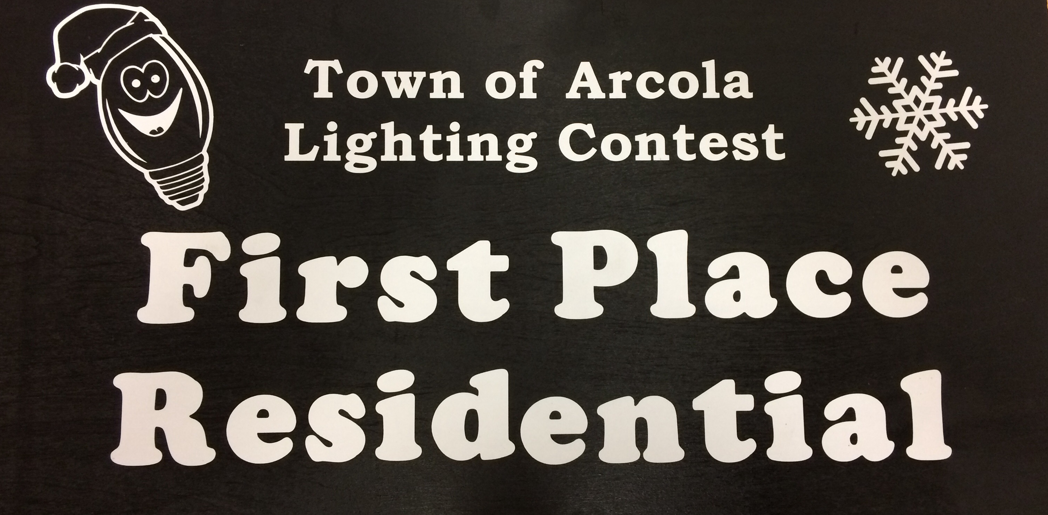
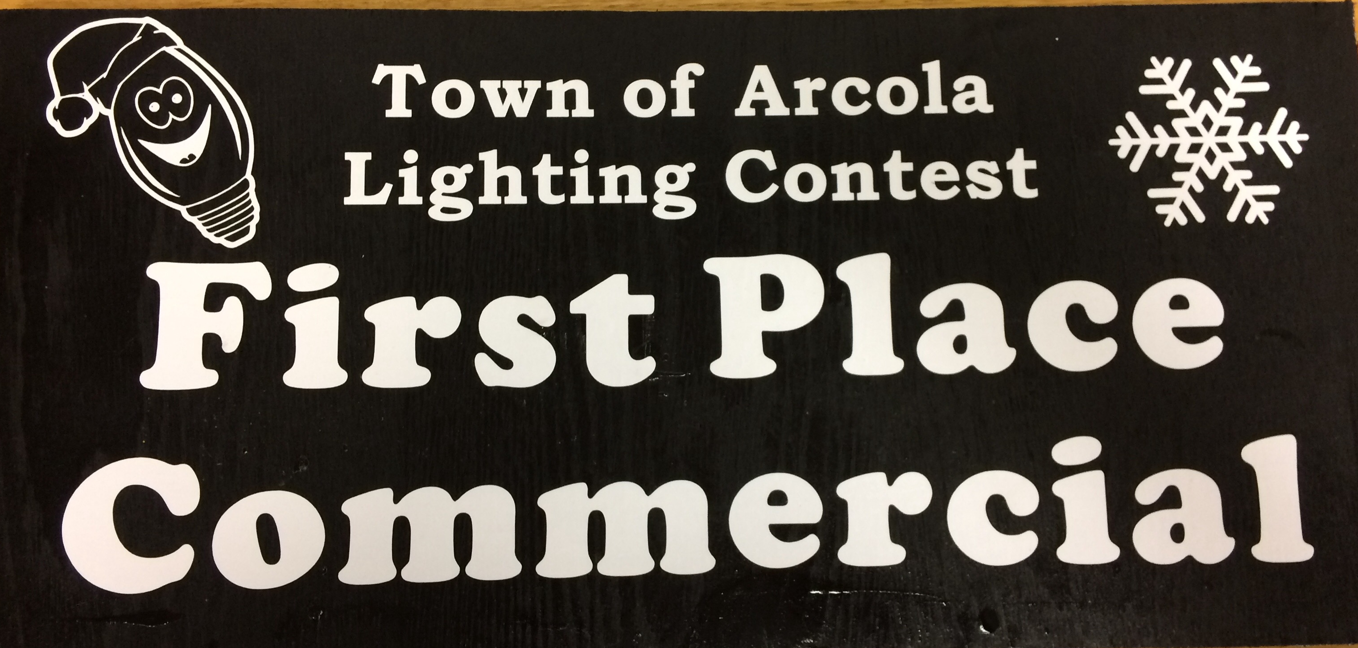

Vandalism

There have been some reports of vandalism around town as well as numerous break-ins and items being stolen. We just want to remind residents to keep your vehicles and houses locked and to keep a look out for your neighbours.



